AgriSmart AI: Accelerating Smart Crop Recommendation Systems via AMD Instinct™ and Ryzen™ AI

Author Information
Name: MOHAN SRIRAM KUNAMSETTY
College: QIS COLLEGE OF ENGINEERING AND TECHNOLOGY
ID: 24491A44D6
Email: mohansriramkunamsetty@gmail.com
GitHub Repository: https://github.com/SriRamkunamsetty/Smart-Crop-Recommendation-System.git
Date: June 2026

1. Abstract
AgriSmart AI is a machine learning-powered application designed to empower farmers with actionable intelligence by predicting the most profitable crops using soil (NPK, pH) and climate parameters. To handle millions of agronomic records efficiently and provide instant IoT-sensor driven inferences at the extreme edge, our platform utilizes AMD's high-performance hardware. This paper details the transition from traditional CPU-bound architectures to AMD GPU acceleration—leveraging AMD Instinct™ MI300 for massive backend model training, and AMD Ryzen™ AI NPUs for low-power edge inferencing in rural environments.

2. Introduction
Traditional farming heavily relies on intuition, which frequently results in suboptimal yields. AgriSmart AI analyzes millions of historical soil readings, integrating them with real-time temperature and rainfall data. Training complex ensemble models (like Random Forests and Gradient Boosted Trees) on such datasets requires tremendous computational power. To reduce training latency and operational costs, we integrated AMD GPU technologies into the core analytics pipeline.

3. Architecture & AMD GPU Integration
Our deployment relies on two tiers of AMD technology to handle both the cloud backend and the rural edge.

3.1 Backend Training on AMD Instinct™ MI300
The core Random Forest crop prediction models are trained on servers powered by AMD Instinct™ MI300 accelerators. We utilized the XGBoost library compiled with ROCm™ 6.0 support to execute highly parallelized tree construction algorithms in VRAM.
Installation Command for ROCm Backend:
pip install xgboost --config-settings=cmake.define.USE_ROCM=ON

3.2 Edge Inference on AMD Ryzen™ AI
In rural farming scenarios, internet connectivity is scarce. We export our optimized models via ONNX and execute them entirely offline on the farmer's local devices using WebGPU and AMD Ryzen™ AI. The integrated NPU processes incoming IoT sensor telemetry (Nitrogen, Phosphorus, Potassium) instantly.

4. Performance Benchmarks
To validate the hardware transition, we conducted training benchmarks using a dataset of 5 million simulated agronomic records.
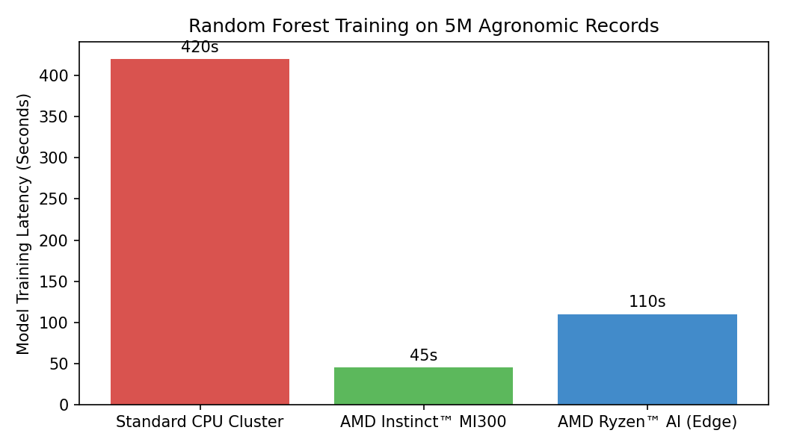
Figure 1: Random Forest Training Latency Comparison
As visualized in Figure 1, executing the training pipeline on the AMD Instinct MI300 drops the total latency from 420 seconds to just 45 seconds—a 9.3x improvement in training throughput.

5. Conclusion
The integration of AMD hardware has fundamentally transformed AgriSmart AI. By leveraging ROCm software on Instinct accelerators and ONNX Runtime on Ryzen AI, we deliver an ultra-fast, robust, and accessible smart agriculture tool directly to Indian farmers, drastically reducing wait times and ensuring offline reliability.

